|  |
| --- |
| *Company name – Twitter* |
| Development Specification:  Use Case for the system *system name* |
| Document creation date: *29.04.2018*  Version: *version 2.0, 04.05*  Authors:  *Adrianna Buda, Krzysztof Kopleński, Piotr Szczepański* |

**History of document versions**

|  |  |  |  |
| --- | --- | --- | --- |
| **Version number** | **Date** | **Authors** | **Version description** |
| ver_1 | 29.04.2018 | AB | Use case diagram added |
| ver_2 | 06.05.2008 | AB | Use case diagram changed, terminology added |
| ver_3 | 14.05.2008 | JK | Description |
| ver_4 | 14.05.2008 | JK | Description |

Table of contents

Table of contents 2

Terminology 3

Actors description 4

Actor 1: *name* 4

Actor 2: *name* 4

Actor 3: *name* 4

System 4

Use case diagram 5

Use cases 6

Symbol: Use case name 6

Symbol: Use case name 6

Terminology

|  |  |
| --- | --- |
| **Term** | **Definition** |
| User |  |
| Follower |  |
| Tweet |  |
| Hashtag |  |
| Server |  |
|  |  |
|  |  |
|  |  |
|  |  |
|  |  |

Actors description

In this system following actors are specified:

Actor 1: *User*

Description

Actor 2: *Follower*

Description

System

*Project based on Twitter idea. We’re developing a system with a mobile application in which user can login/log out, write tweets(no edition and removal allowed). User can follow other users, search them (also typing hashtags) and put some tweets for later.*

Use case diagram

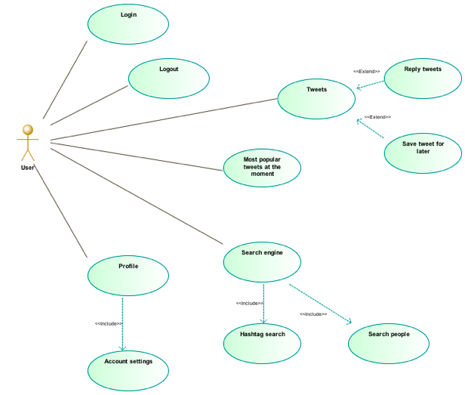Use cases

Symbol: Twitter use case v.1.0

**Primary actors:** User

**Other actors:** Folower

**Modification date:** 29.04.2018

**Preconditions:**

**Post conditions**:

**Summary:**

**Scenario:**

**Extentions:**

**Comment**

Symbol: Twitter use case v.2.0

**Primary actors:** User

**Other actors:** Follower

**Modification date:** 6.05.2018

**Preconditions:**

**Post conditions**:

**Summary:**

**Scenario:**

**Extentions:**

**Comment**